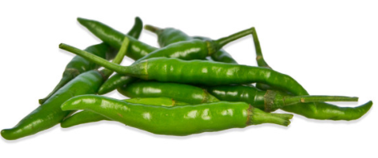
Ignacio’s 2nd Annual Green Chile Cook Off
Saturday Sept 8, 2018

Name_____________________________________________________
Address ___________________________________________________
Contact Number______________________ or ______________________

Category entering: (you may enter as many categories as you wish. All Chiles must be cooked on site. Salsa may be brought in that day) Green_________ Salsa_________
Type of Meat Requested_______________________ # Lbs Requested________
Amount of roasted green chile needed (# of Lbs)___________________________

I will be cooking my chili on a hot plate ______ grill ______or camp stove______
Will you need Electricity? Yes_____ No_____ (Please bring your own extension cords)

Are you participating as an individual or a business? _______________________

1st & 2nd Place and People’s Choice awarded in each category.

I have read and agree to abide by all the rules of the event hosted by Farmers Fresh Market and the Ignacio Chamber of Commerce. We shall indemnify, defend and hold Farmers Fresh Market, Ignacio chamber of Commerce, all sponsors, their officers, agents, employees and volunteers harmless from any and all claims, suits, actions, damages, or causes of action which the Ignacio 2nd Annual Chile Fest or 2nd Annual Green Chile Cook-off may incur out of any personal injury, loss of life or damage to any property, whether business or personal. I am responsible for ensuring that my team and I conduct ourselves in a professional manner at all times. We understand that Farmers Fresh Market or The Ignacio Chamber of Commerce has the right to request an team or an individual to leave the event at any time should there be aggressive or inappropriate behavior.

Signature ______________________________________ Date ______________________

